Global Geopark Network-The Annual Report 2018 of Leye-Fengshan UNESCO Global Geopark

- Identity
Name, County, Region
Leye-Fengshan UNESCO Global Geopark, China, APGN
Year of designated / Year of last revalidation: 2010, 2018
Representative pic:
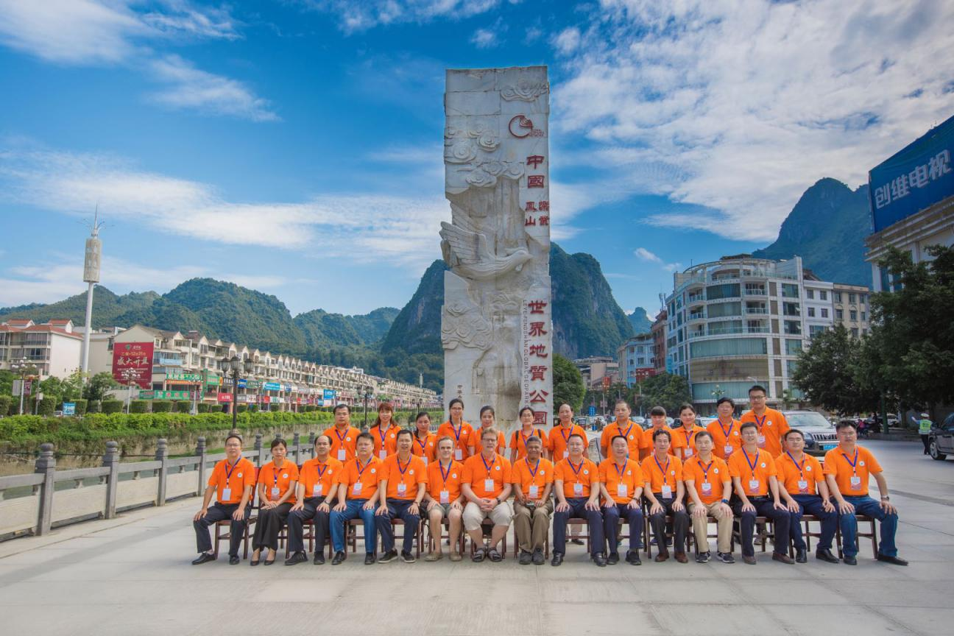
The annual activities of important---Leye-Fengshan UGGp finished field excursion and evaluation work that was assigned by executive bureau of Global Geopark of UNESCO in July, 2018.

- Geopark’s Data

Number of Staff: 45 staff, 2 geologists included
Number of Tourists: 205,2000
Number of activities: 22
The Geopark held the national outdoor activity of exchange expedition & rescue skills, CNSAS-CRC, the 1st China cave rescue comprehensive drill, the 29th Sino-British cave expedition & exploration activity; The annual joint international cave exploration activities and “March 3rd” festival of Zhuang ethnic minority, specific-themed exhibition “Charming Geology---The geoarks in China”, the earth day activity with the theme “Cherish natural resources, protect beautiful land---Start from me” were held; The promotion activity of the 28th international day for disaster reduction were conducted; Cooperated with the Geoparker of China Geology University, in the form of popular science lectures, 4 activities of science popularization knowledge into campus were held; Promoted science popularization play---The little ant’s adventure in Tiankeng, took part in the 6th national science acting competition and etc.
Number of school classes for Geopark education: 6 classes, 1450 people
Number of news/messages released:
2 pieces of news were released in GGN, 42 pieces of news were released in Leye-Fengshan UGGp website, 9 pieces were released on other medias.
- Geopark’s activities
Main achievements in 2018
Cooperated with many caving organizations from all over the world, including French Caving Federal, British Expedition Association to launch cave expedition & exploration activities. From Oct. 4th to 15th of 2018, the honorary president of International Cave Federal, Andy·Evans led an British exploration group of 10 people to work with Institute of Karst Geology of Chinese Academy of Geological Science to make a 3D laser scan for Hong Kong·Haiting cave chamber that was found in 2017. The volume was determined to be 3.53 million cubic meters, ranking 10th in the world; The projection area in the bottom of the cave is 77,600 square meters, ranking 3rd in the world. The experts team scanned the Yangguang chamber of Maoqi cave accurately again, the volume of 6.67 million cubic meters was found, ranking 3rd in the world, the height from subterranean river to Maoqi cave up to 450 meters, ranking the 1st in the world. According to the preliminary and this 3D scanning results, the average volume of Yangguang cave chamber, Hongmeigui cave chamber, Hong Kong·Haiting cave chamber, Mawangdong cave chamber, Marco Polo cave chamber, Chuanglongyan cave chamber within the Geopark is more than 1 million cubic meters. Among the top 10 karst cave chambers, three of them are located in Leye-Fengshan UGGp, including Yangguang chamber, Hongmeigui chamber, Hong Kong·Haiting chamber, of which the Hongmeigui chamber has a volume of 5.25 million cubic meters.
Contribution to GGN--- Network activities & Participation
Took part in the activity “Culture and Nature heritage Day---Beautiful Danxia” of Guangdong province 2018, workshop on Geosites Gonservation and Planning, Construction & Management for Geopark, the 23rd national cave academic conference & the 5th council meeting, the 8th International Conference on UNECO Global Geoparks, visited the sister geopark---Eisenwurzen UNESCO Global Geopark of Austria, participated in “Opening ceremony on Keketuohai UNESCO Global Geopark & Application and Revalidation Symposium on Global Geoparks 2018”, the 4th International Course on UNESCO Global Geoparks Management and Development, the annual meeting of China Global Geoparks 2018.
Management & Finance status
The management institution of Leye-Fengshan UGGp was established in October, 2011. The Leye-Fengshan UGGp is completely managed by the committee and is executed by Leye administration and Fengshan administration.
The Geopark owns independent financial budget which takes charge of compiling annual budget. The income mainly comes from tickets revenue and the superior special expenditure. Among them, the scenic areas of the Geopark received 2.052 million visitors and the tickets revenue reached 187 million yuan, and got the special expenditure of 9.372568 million yuan in 2018.
Geoheritages conversation
First, the Geopark has strengthened the effort patrol on the geoheritages conversation. Introduced atmosphere environment monitoring equipment to monitor the Geopark’s atmosphere, water, air and etc. Besides that, assigned some patrollers and propagandists who have common sense and responsibility to unify self-awareness of geoheritages protection of local residents and encouraged them to protect the Geopark.
Second, we has increased promotion of geoheritages conversation. To enhance people’s awareness of security and protection by launching publicity activities like “Earth Day” and distributing more than 1000 copies of brochures to popularize knowledge.
Third, the Geopark accelerated the implementation of projects to protect geological relics.
- New projects. ① The project of exhibition hall and science popularization hall of Waili PT boundaries in Jinya village have been completed. ② The project of teenagers science popularization education centre was invested of 3.25 million yuan in total. Construction: the wall keel, wall plasterboard, wall aluminum were installed. The panda exhibition table, screen holders and animals wall exhibition holders have been installed already. The track spotlights, the cracks of aluminum boards, partial raised panels on an inclined wall, fossils showcases are installing. Landscaping: sound board in the screening room, the aluminum rectangular tubes on the top, the partial suspended ceiling of animals and plants hall have been installed. The bamboo rafts of natural bridge, fossils and stratum models are building. The landscaping concrete vegetation and colors on the second floor have been finished. We are trying our best to promoting the work on text proofreading of the interpretation boards and specimen purchasing.
- Continued projects. ① Integration project of layout, design and construction of Leye geomuseum. The multimedia equipment has been installed and 4D cinema can be used. The sand table, academic lecture hall and VIP room have been finished. Voice navigation system has been put into use, and we are planning to ask the third party to finish audit work in 2019. ② The main structure of Sanmenhai tourists distribution center has been completed. ③ The construction project of smart monitoring system in the Geopark. 33 cameras in 12 spots have been installed and the machine room has been finished. ③ The construction area of 19,766.75 meters of walking paths, guardrails, platforms has been finished in the Geopark, 2 sightseeing platforms, 8 eco-toliets and 15 kilometers of travel roads have been completed as well.
Sustainable tourism (Geotourism)
Since the the establishment of the Geopark, it has driven the sustainable development of local economy, especially the tourism and catering. 6 three -stars hotels and 3 four-stars hotels were approved in 2018. Newly opened 25 medium and small sized restaurants. The new recruitment of over 180 people work for tourism, more than 300 people work for catering.
New educational plans about geoheritages conversation, sustainable development and disaster risk reduction
We held 4 activities successfully, such as the national outdoor activity of exchange expedition & rescue skills, cave rescue comprehensive drills, Sino-British cave exploration activities; We also launched 12 science popularization activities, such as the special subject exhibition of “Earth Day”, publicity activity for international disaster reduction and etc; More than 1000 brochures were distributed to popularize the knowledge of the Geopark and improve people’s sense of security and protection; The Geopark participated in training workshop on geological relics conservation and management and construction for the geoparks, the 23rd national cave academic conference & the 5th council meeting, the 4th International Course on UNESCO Global Geoparks Management and Development.
Strategic partners
Related government departments: Tourism Development Committee, Land & Resources Bureau, Agriculture Bureau, Education Bureau, Science $ Technology Bureau, Culture, Broadcast,News & Sports Bureau, Development & Reform bureau, Animal Husbandry Bureau, Transportation Bureau, Housing $ Construction Bureau, Environmental Protection Bureau, Water Conservancy Bureau; Tourism enterprises: tourism companies, travel agencies, hotels, agritainments and etc. Science research partners: Institute of Karst Geology of Chinese Science Academy, University of Geneva, University of Zurich, University of Lyon of France, University of Munich of Germany, China University of Geosciences (Wuhan), University of Guangxi, Normal University of Guangxi, Guilin Tourism College and etc. Other conservation areas: National forest park, orchid base, planting base, breeding base and etc; Other geoparks which established sister geoparks with us.
Publicity & Promotion activities
The Geopark took part in international tourism exhibition of Guangdong, tourism exhibition of China-Asean expo 2018, China international tourism fair of Shanghai; We put on 2 advertisements on the boards along the Du’an-Baise and Nanning- Baise highway to show and build the Geopark’s tourism impression directly and improve the promotion of the Geopark’s tourism, and expand further the popularity and influence of the Geopark.

4. Contacts:
Manager: Ban Guiqiang (Fengshan subarea), Huang Hehuan (Leye subarea)
E-mail: lefgeopark@163.com
Science consultant (geologist): Zhang Yuanhai, Jean·Bottazzi
E-mail: 646509080@qq.com

